Apprentice Talent Profiles
Where could your talent take you?
Name: | Dean Wane | 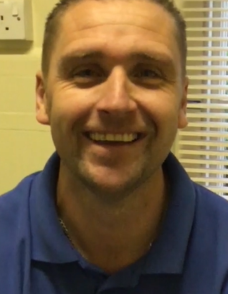
Job: | Mechanical Craftsman
Email:
Details/date: | 15/10/2018

Where are you based? | Lincoln County Hospital working for United Lincolnshire Hospitals NHS Trust
Tell us a bit about your current role | I currently work for the Estates department, as a mechanical craftsman. I am currently here as a plumber, but because we are mechanical craftsmen, we do things like steam leaks, air handling, blocked toilets, tap revivers, and anything else that comes in on the iPads we have.
How long have you been with the Trust? | I have been here for three years, the Talent Academy took me on as an apprentice.
Looking at your own training and development, could you tell us more about the early stages of your career? | I have been plumbing for over 15 years now, was doing long hours, driving as far as Skegness or Hunstantion.  I originally came here as agency staff and then the job came up.  They (in the job description) said the job would involve doing an apprenticeship at Lincoln College.
Are you currently undertaking any study? | I am currently doing my level 3 at Lincoln College.
Has the apprenticeship help support you on your pathway? | Of course, hopefully out of the training I will become a level 3 plumber.
The apprenticeship programme offers blended learning, consisting of on and off-the-job training. This enables the learner to understand and apply their learning within the context of their day to day role. | The hospital (trust) fund it all, which is very good, rather than me paying for it.  There is opportunity to get training too, if you need it to the role you do.  Management have been very helpful.

